**1. To use the ribbon commands, what menu and grouping of commands will you**

**find the Insert and Delete command?**



Yes in HOME > CELL> INSERT & DELET COMMAND IS THERE.

**2. If you set a row height or column width to 0 (zero), what happens to the row and column?**

It sets to the default width or height.

**3. Is there a need to change the height and width in a cell? Why?**

It is necessary to change width and height in excel to fit the data.

Excel by default provide equal width and height with respect to columns and rows. Whenever we enter a lengthy data, few characters will get displayed and other will be present inside the cell but will be hidden to the user. It is necessary to change the rows and columns height and width to have a good presentation in excel. Few other cells width and height needs to be reduced so that it represents a smaller amount of data such as Gender which accepts ‘F’ or ‘M’.

**4. What is the keyboard shortcut to unhide rows?**

* Ctrl+Shift+_ (underscore)

**5. How to hide rows containing blank cells?**

1. Select the range that contains empty cells you want to hide.
2. On the Home tab, in the Editing group, click Find & Select > Go To Special.
3. In the Go To Special dialog box, select the Blanks radio button, and click OK. ...
4. Press Ctrl + 9 to hide the corresponding rows.

**6. What are the steps to hide the duplicate values using conditional formatting in**

**excel?**

1. Select the range you want to hide duplicates. Here I select range A1:F11.

2. Then click **Conditional Formatting** > **Highlight Cells Rules** > **Duplicate Values** under **Home**tab. See screenshot:

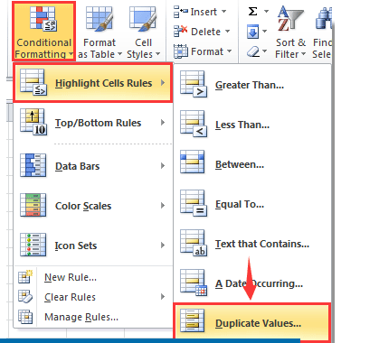

3. In the **Duplicate Values** dialog box, select**Custom Format** in the v**alues with** drop-down list, and then click the **OK** button.

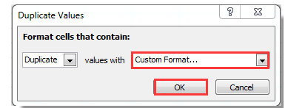

4. In the **Format Cells** dialog box, go to the **Font** tab, and in the **Color** drop-down list, choose a font color which matches the background color of your selected range cell. And finally click the **OK** button. See screenshot:

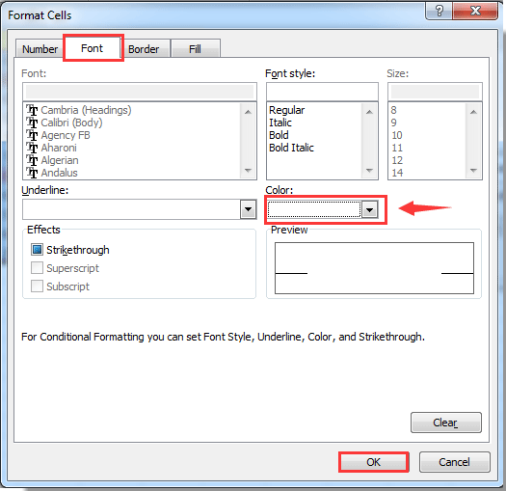

5. When it returns to the Duplicate Values dialog box, click the OK button.

Now all duplicate records in selected columns are hidden immediately.